<<FLASHMOB OF NOVU>>
Name L.Ishitha
Roll no 2420030041
Sec-10

Organized by: KLH University, Bachupally Campus

Dates: 31 October, 2025

Event Summary: (Brief Description in about 100-150 Words)
KLH University organized an energetic and vibrant Flash mob on October 31 as part of the promotional activities for the upcoming Novus Fest. The flashmob
brought the campus to life with music, dance, and excitement, successfully capturing the attention of students and creating enthusiasm for the fest.
Performers showcased synchronized dance moves and engaging choreography, spreading joy and anticipation among the crowd. The event reflected creativity, coordination, and team spirit among the participating students.
Key Highlights: (Brief Description in about 100 Words)
• Dynamic dance performances by student volunteers promoting Novus Fest.
• Created a lively and festive atmosphere across the campus.
• Encouraged teamwork, creativity, and participation among students.
• Attracted a large crowd, generating excitement and awareness about the upcoming event.
• Reflected the enthusiasm and unity of the KLH student community.

My Participation: (Brief Description in about 60-120 Words)
I actively participated in the Flashmob for Novus held on October 31 at KLH University. Being part of the dance performance was an exhilarating experience that allowed me to express creativity and connect with my peers. The teamwork and coordination required for the performance helped me improve my confidence and collaborative skills.
This event was not only fun but also gave me the opportunity to contribute to the promotion of Novus Fest and spread excitement among fellow students.

<<Event Photographs>>

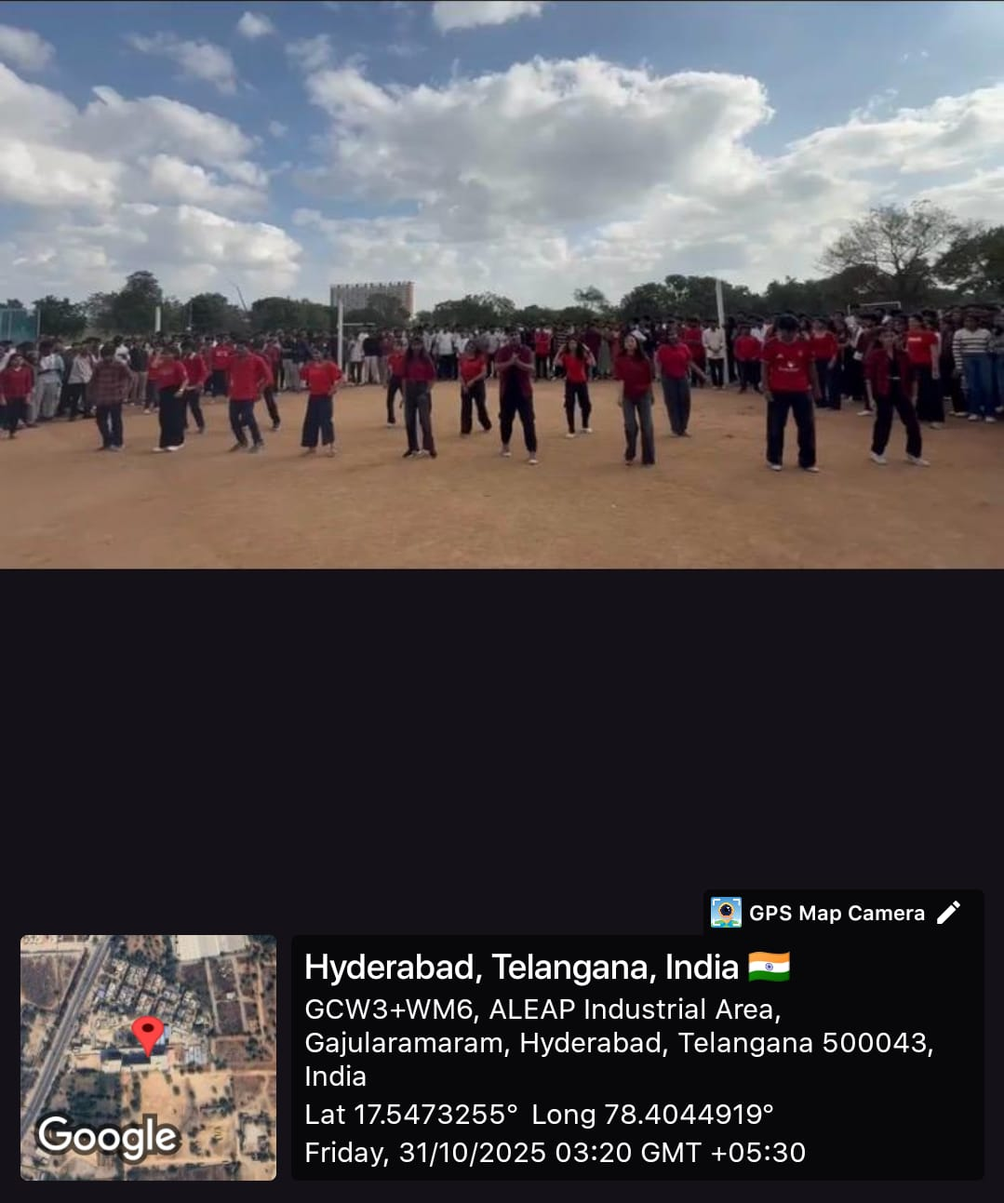

Conclusion:
In conclusion, the Flashmob for Novus was a vibrant and successful event that brought the entire campus together in celebration. It reflected the enthusiasm, creativity, and unity of the students at KLH University. My participation in this event was an enjoyable experience that strengthened my teamwork, stage presence, and sense of belonging to the university community.
Acknowledgment:
I would like to express my heartfelt gratitude to KLH University for organizing the Flashmob for Novus and giving students the opportunity to showcase their talents. Special thanks to the coordinators, choreographers, and participants for their dedication and teamwork in making the event a grand success. The flashmob truly set the stage for the excitement and energy of Novus Fest.

